LAB SKILL 3
NAME: LEE XUAN HUI
MATRIC NO.:A24DW0423

INSTRUCTIONS
Answer all questions. Screenshot your coding and output and paste inside this word answer template.

QUESTION 1
Write a C++ program that asks the user to input a number. Use a while loop to print all even numbers from 2 up to that number (inclusive). For example, if the user enters 10, the program should output: 2, 4, 6, 8, 10.

CODING
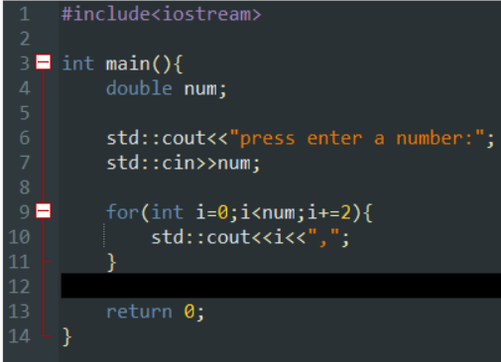

OUTPUT
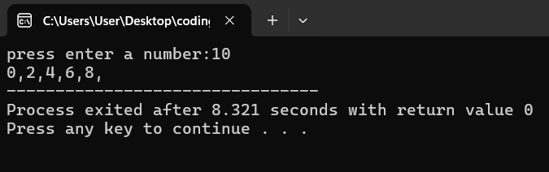

QUESTION 2
Write a C++ program that calculates the sum of all positive integers entered by the user. Use a do-while loop to repeatedly ask the user to enter numbers. The loop should stop when the user enters a negative number, which should not be included in the sum. Display the sum after the loop ends.

CODING
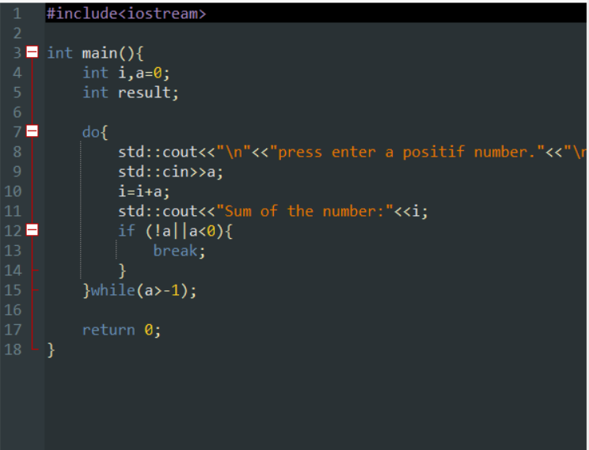
OUTPUT
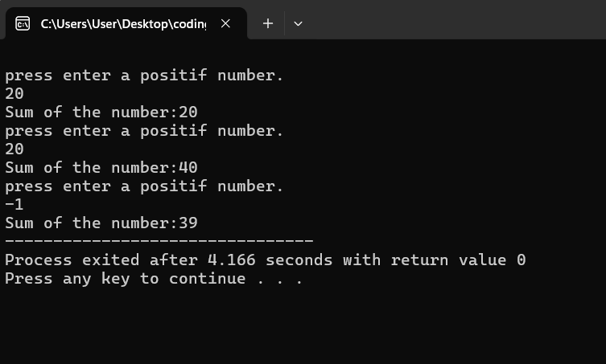
QUESTION 3
Write a C++ program that generates the multiplication table for a number entered by the user. Use a for loop to display the multiplication table from 1 to 10. For example, if the user enters 5, the program should output:

5 x 1 = 5
5 x 2 = 10
5 x 3 = 15
...
5 x 10 = 50

CODING
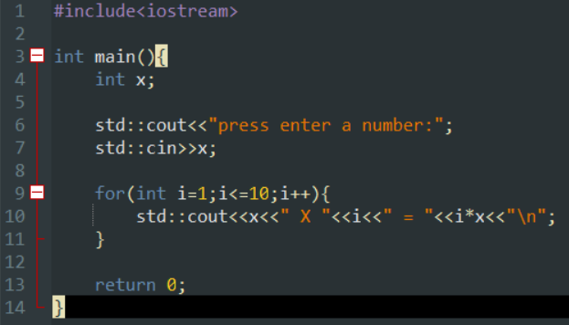

OUTPUT
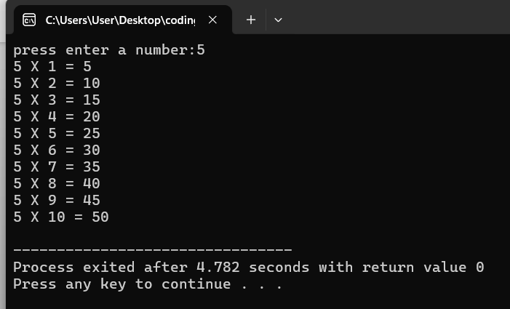

QUESTION 4
Write a C++ program that prints a right-angled triangle pattern of numbers. Use nested loops to print the pattern. The user should specify the height of the triangle. For example, if the user enters 4, the program should output:

1
1 2
1 2 3
1 2 3 4

The outer loop controls the number of rows, and the inner loop controls the numbers in each row.

CODING
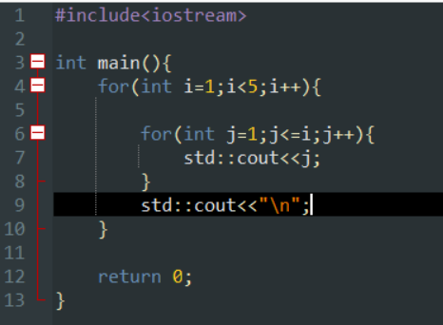
OUTPUT
